18/10/2026 NAME: Charulatha.V
Experiment :1 REG.NO.:192424031
SLOT: A
SEMESTER:MS2 September 2026
COURSE CODE:CSA4701
COURSE NAME:Deep Learning

Vector and Matrix Operations for Deep Learning
Scenario:
A neural network receives input features representing a student's study hours, attendance, and assignment scores. Create vectors and matrices to represent the data and perform matrix multiplication to calculate weighted outputs.
Algorithm:
- Start the program.
- Import NumPy and Matplotlib libraries.
- Create a matrix containing student data: study hours, attendance, and assignment scores.
- Create a weight vector to assign importance to each input feature.
- Normalize the study hours to a percentage scale.
- Perform matrix multiplication between the student data matrix and the weight vector using np.dot().
- Display the input matrix, weight vector, and calculated weighted outputs.
- Plot a bar chart to compare the weighted outputs of students using Matplotlib.
- Display the graph and analyze the student performance scores.
- Stop the program.

Source code:
import numpy as np
import matplotlib.pyplot as plt

# Student data: Study Hours, Attendance (%), Assignment Score (%)
students = np.array([
[5, 80, 70],
[7, 90, 85],
[3, 65, 60],
[8, 95, 90]
])

student_names = ["Student 1", "Student 2", "Student 3", "Student 4"]

# Feature weights
weights = np.array([0.3, 0.3, 0.4])

# Normalize study hours to a percentage out of 10 hours
normalized_students = students.astype(float).copy()
normalized_students[:, 0] = normalized_students[:, 0] * 10

# Matrix multiplication
weighted_outputs = np.dot(normalized_students, weights)

# Display input matrix and weight vector
print("STUDENT DATA MATRIX:")
print(students)

print("\nWEIGHT VECTOR:")
print(weights)

print("\nWEIGHTED OUTPUTS:")
for name, output in zip(student_names, weighted_outputs):
print(f"{name}: {output:.2f}%")

# Summary table
print("\nSUMMARY TABLE")
print("-" * 57)
print(f"{'Student':<12}{'Study Hours':<13}{'Attendance':<13}"
f"{'Assignment':<12}{'Output':<8}")
print("-" * 57)

for name, data, output in zip(student_names, students, weighted_outputs):
print(f"{name:<12}{data[0]:<13}{str(data[1])+'%':<13}"
f"{str(data[2])+'%':<12}{output:.2f}%")

# Plot 1: Weighted output comparison
plt.figure(figsize=(8, 5))
plt.bar(student_names, weighted_outputs)
plt.xlabel("Students")
plt.ylabel("Weighted Output (%)")
plt.title("Student Performance - Weighted Outputs")
plt.ylim(0, 100)
plt.grid(axis="y", linestyle="--", alpha=0.4)
plt.tight_layout()
plt.show()

# Plot 2: Input feature comparison
plt.figure(figsize=(8, 5))
x = np.arange(len(student_names))
width = 0.25

plt.bar(x - width, students[:, 0] * 10, width, label="Study Hours (%)")
plt.bar(x, students[:, 1], width, label="Attendance (%)")
plt.bar(x + width, students[:, 2], width, label="Assignment Score (%)")

plt.xlabel("Students")
plt.ylabel("Score (%)")
plt.title("Comparison of Student Input Features")
plt.xticks(x, student_names)
plt.legend()
plt.grid(axis="y", linestyle="--", alpha=0.4)
plt.tight_layout()
plt.show()

# Plot 3: Feature weights
plt.figure(figsize=(6, 5))
plt.pie(weights, labels=["Study Hours", "Attendance", "Assignment Score"],
autopct="%1.1f%%", startangle=90)
plt.title("Neural Network Feature Weights")
plt.tight_layout()
plt.show()

# Result
best_index = np.argmax(weighted_outputs)
print("\nRESULT:")
print(f"Highest weighted output: {student_names[best_index]}")
print(f"Weighted score: {weighted_outputs[best_index]:.2f}%")
Output:

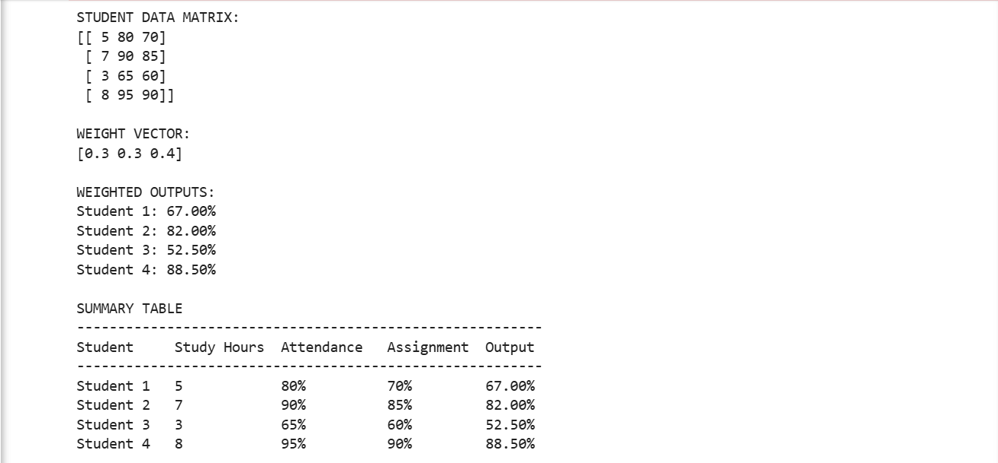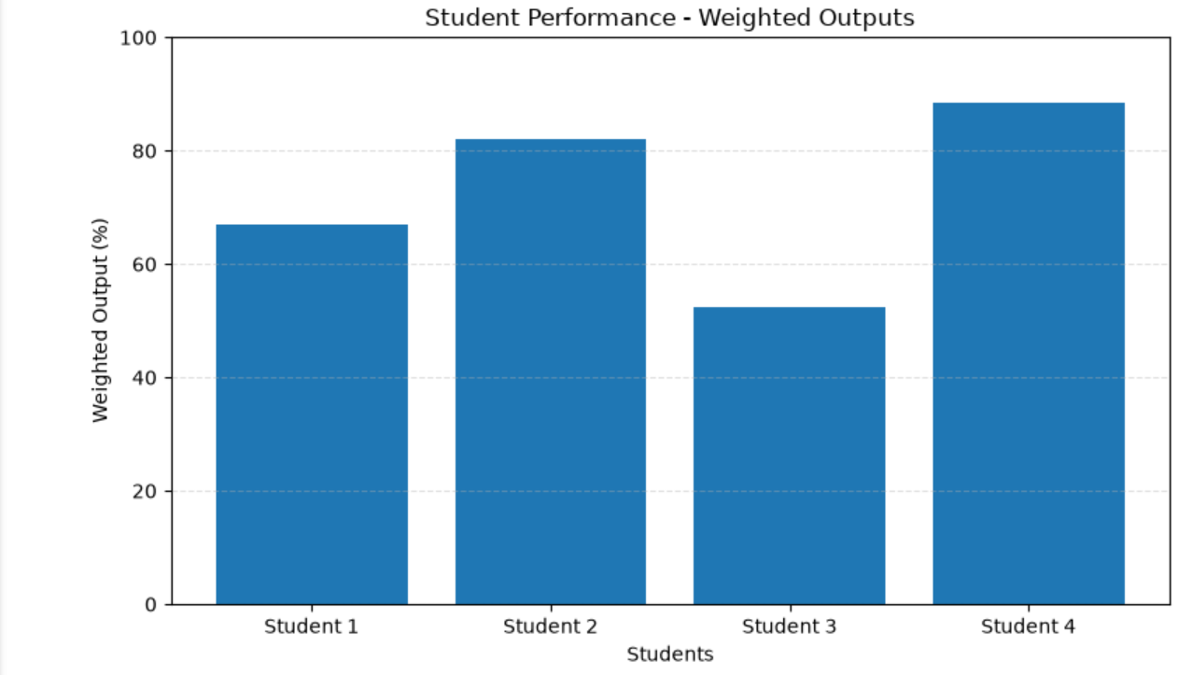
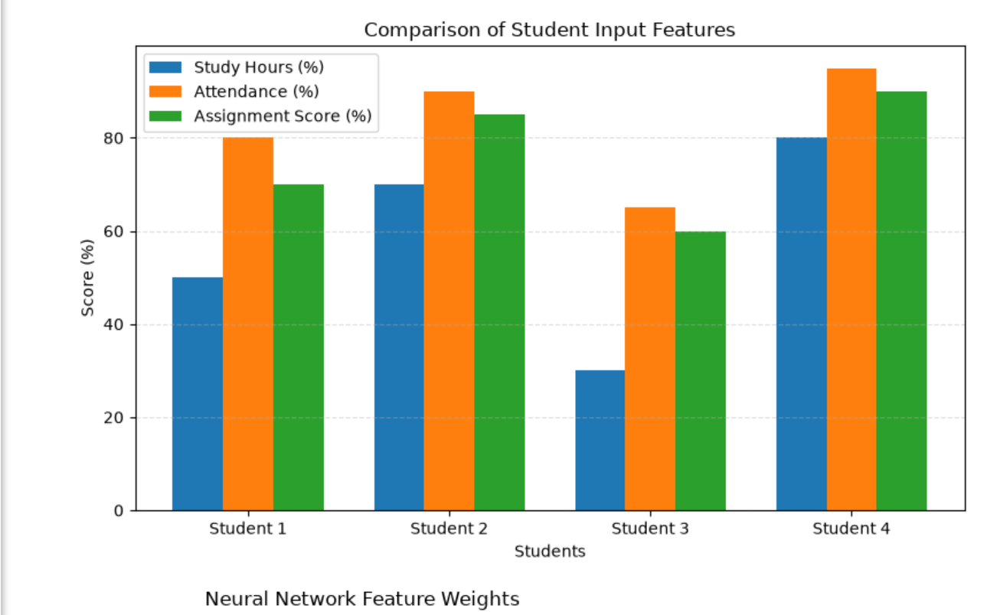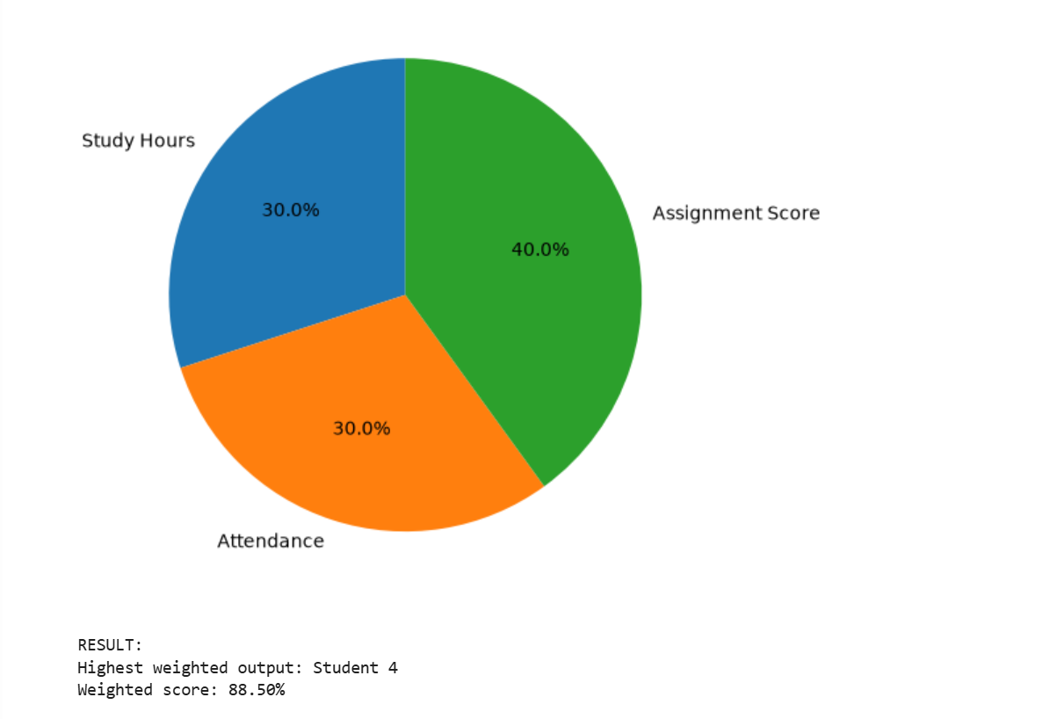
Result:
Thus, vectors and matrices were created using NumPy, and matrix multiplication was performed successfully to calculate the weighted outputs of students. The results were visualized using Matplotlib to compare student performance.

